

**SECI 1113 - 07**

**System Analysis and Design**

# 

**Phase 2**

**Project**

**Group**

|  |  |
| --- | --- |
| **Name** | **Matric No** |
| Alaa Eddin Hussain Albashir | A23CS0008 |
| Justin Fauzadani Azka | A23CS4012 |
| KNAN FADI DAWARH | A23CS4013 |
| Asqy Tarmidzy | A23CS4021 |

### 

# 

# 

# 

# 

# 

# 

# 

# 

# 

# Table of Contents

**Information Gathering Process 3**

**Methodology for Gathering Information 3**

**Summary of methods used 4**

## 

# 

# 

# 

# 

# 

# 

# 

# 

# 

# 

# 

# 

# **Overview of Project.**

# Having a manufacturing company with lots of problems in their management practices because of manual ways of working that got a lot of mistakes. Problems have many things like no stocks, too many stocks, production stops, more costs, customers not happy. A project wants to help with all of this; it called Enhanced Inventory Management System (EIMS). The idea is to make the company's management easier and better using new technology and good ways that other companies use. It will help track stocks in real time, ordering things when it needs, managing suppliers well, knowing the demand, and working smoothly with making plans.

# 

# 

# 

# 

# **problem Statement .**

# Presently, inventory managing traditions at Manufacture Company aren't optimal, and they are vulnerable to mistakes. Manual operations, like putting in data and keeping records on paper, generate inaccuracies, creating discrepancies between documented and genuine inventory levels. The lack of real-time insight into stock movings worsens these problems, leading to frequent shortages, surplus inventory, disruptions in production schedules, and increased operational expenses. Additionally, the lack of dependable forecasting methods impedes the company's capacity to predict demand patterns and strategize sourcing and production tasks efficiently. These inadequacies undermine the company's ability to work with quickness, precision, and cost-efficiency, affecting its competitiveness and profitability in the marketplace.

# 

# 

# 

# 

# **Suggested Resolutions.**

# More suggested solutions are required to tackle the identified challenges in the problem issue, hence, the Enhanced Inventory Management System (EIMS) is hinted. EIMS contains the subsequent crucial aspects:

# Real-time Inventory Tracking and Observing: Furnishes stakeholders with visibility onto inventory levels crossways many spots, enabling for precise tracking of inventory movements.

# Automated Reordering: Implements reorder points and demand forecast calculations to automatically replenish the process, ensuring timely procurement of substances and constituents.

# Supplier Managing: Embraces a strong supplier managing component that facilitates interaction with suppliers, assesses their performance, and optimizes procurement operations.

# Demand Prediction: Engages sophisticated forecasting techniques to foresee demand patterns precisely, enabling proactive inventory management and reducing stockouts.

# Integrating with Production Planning: Seamlessly combines with production planning processes to harmonize inventory levels with production schedules, reducing interruptions and maximizing efficiency.

# Reporting and Analysis: Furnishes comprehensive reporting and analysis abilities, offering stakeholders with insights onto inventory performance, spotting trends, and empowering data-driven decision-creating.

# By implementing EIMS, the manufacturing corporation can smoothen inventory managing operations, shrink operational charges, minimize stockouts and surplus inventory, escalate production efficiency, boost consumer joy, and preserve a competitive edge in the market.

# 

# 

# 

# 

# 

# 

# 

# 

# 

# 

# 

# 

# 

# 

# 

## 

# Information Gathering Process

**Method for Information Gathering**

Design of Survey and Spread

Objective:

The survey was aimed to gather feedback and ideas from employees in Manufacturing Company on the current practices of inventory management, its efficiency, struggles, and possible enhancements.

Development of Survey:

A structured survey was created with eight questions aiming to collect both numeric and verbal data. The questions focused on key aspects of inventory management:

Familiarity with existing practices of inventory management.

Evaluation the effectiveness of the current system.

Facing struggles connected with inventory management.

Primary struggles met with the existing system.

Effects of mistakes in inventory on daily activities.

Consequences of running out of stock or having excess stock on production schedules or customer deliveries.

Suggested resolutions to tackle the struggles.

Dream for the introduction of automatic reordering and demand forecasting.

Method of Distribution:

The survey was spread electronically to 20 employees in Manufacturing Company. These employees were chosen to represent a varied range of functions and duties linked to inventory management. An online survey platform was use for simple access and submission of responses.

Collection and Analysis of Data

Collection of Responses:

The survey was open for one week.

Reminders were sent to boost participation.

The online platform automatically collects and sorts responses.

Analysis of Numeric Data:

Answers to multiple-choice questions were analyse to spot trends and patterns. Percentages and tally were compute to establish familiarity with inventory practices, the perceived efficiency of the system, and the frequency of struggles faced.

Analysis of Verbal Data:

Responses to open-ended questions were analyse to identify common themes and specific problems. Techniques of content analysis were put to use to categorise primary challenges, the impact of inaccuracies, and the potential benefits of suggested solutions.

## Summary of methods used

Objective:

To collect feedback on inventory management practices at Manufacturing Company from a representative sample of employees.

Questionnaire Development:

A structured survey with eight questions was created, combining multiple-choice and open-ended formats to gather both quantitative and qualitative data.

Distribution Method:

The survey was distributed electronically to 20 employees using an online platform, allowing easy access and response submission. Employees selected for the survey represented various roles related to inventory management.

Data Collection:

Respondents had one week to complete the survey, with reminders sent to ensure a high response rate. The online platform collected and organised responses automatically.

Data Analysis:

Quantitative Analysis: Multiple-choice responses were analysed to identify trends, calculate percentages, and determine common opinions.

Qualitative Analysis: Open-ended responses were analysed to identify common themes, categorise specific issues, and extract meaningful insights.

This mixed-method approach effectively captured a comprehensive view of the current inventory management practices, highlighting key challenges and potential solutions to enhance efficiency and accuracy.

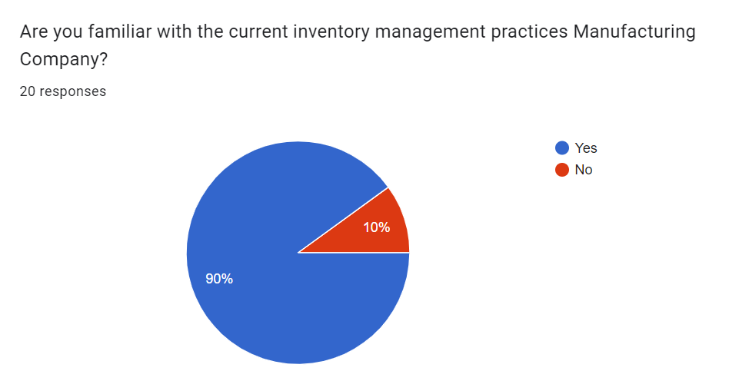

## 

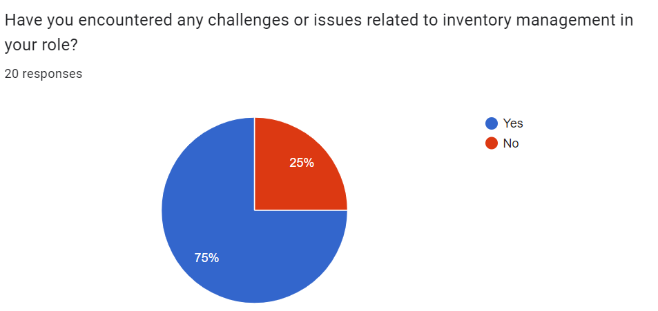

## 

## 

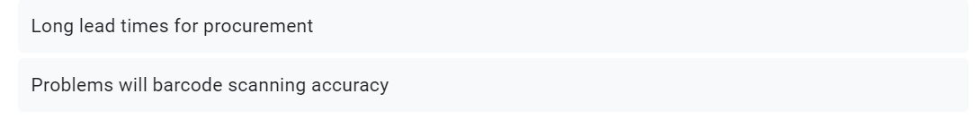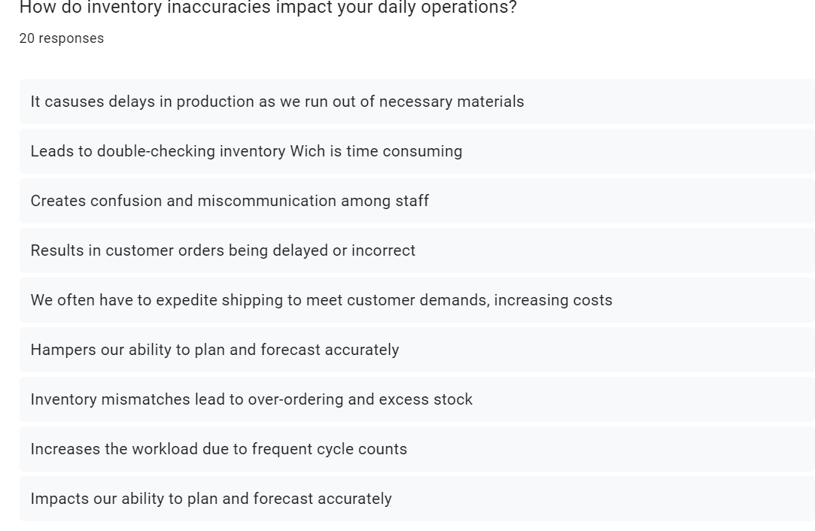

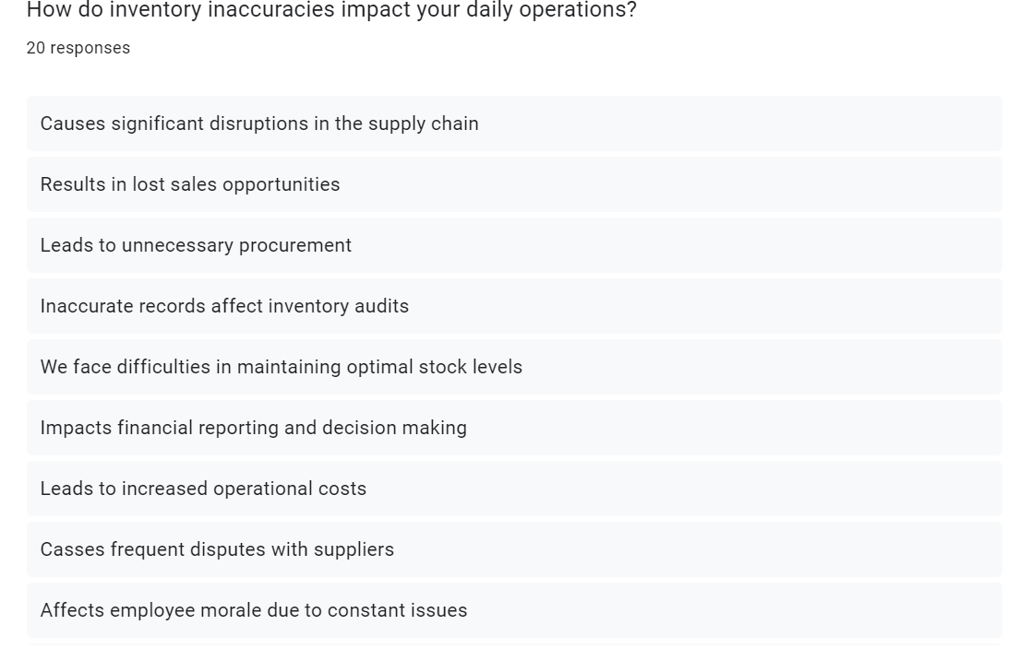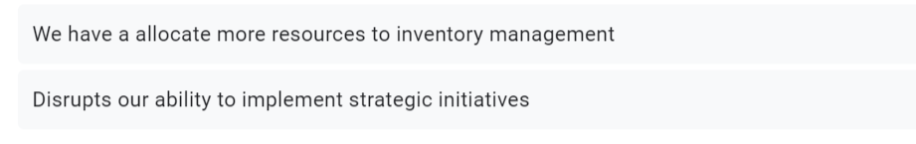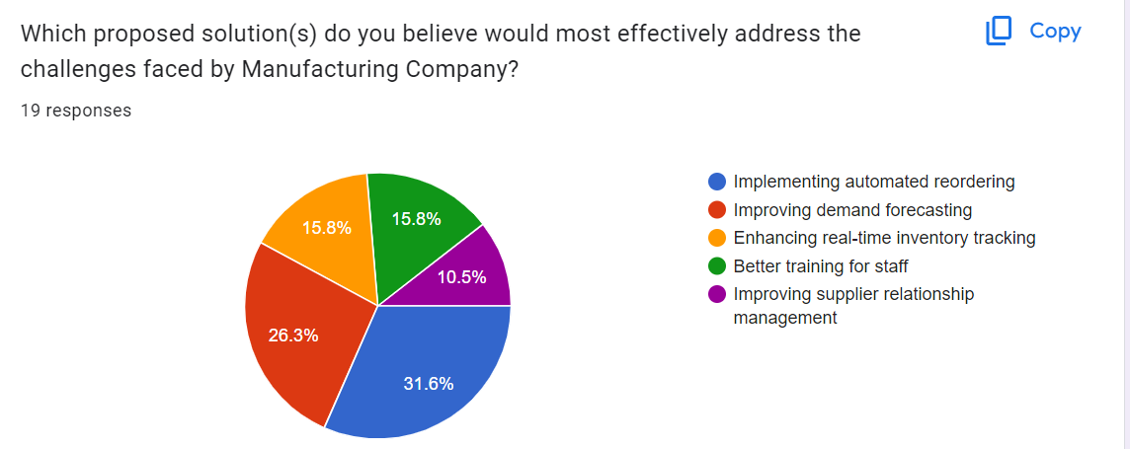

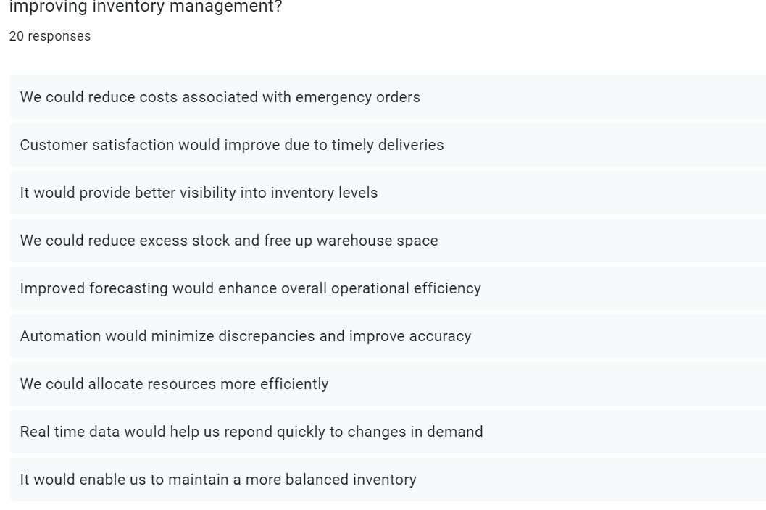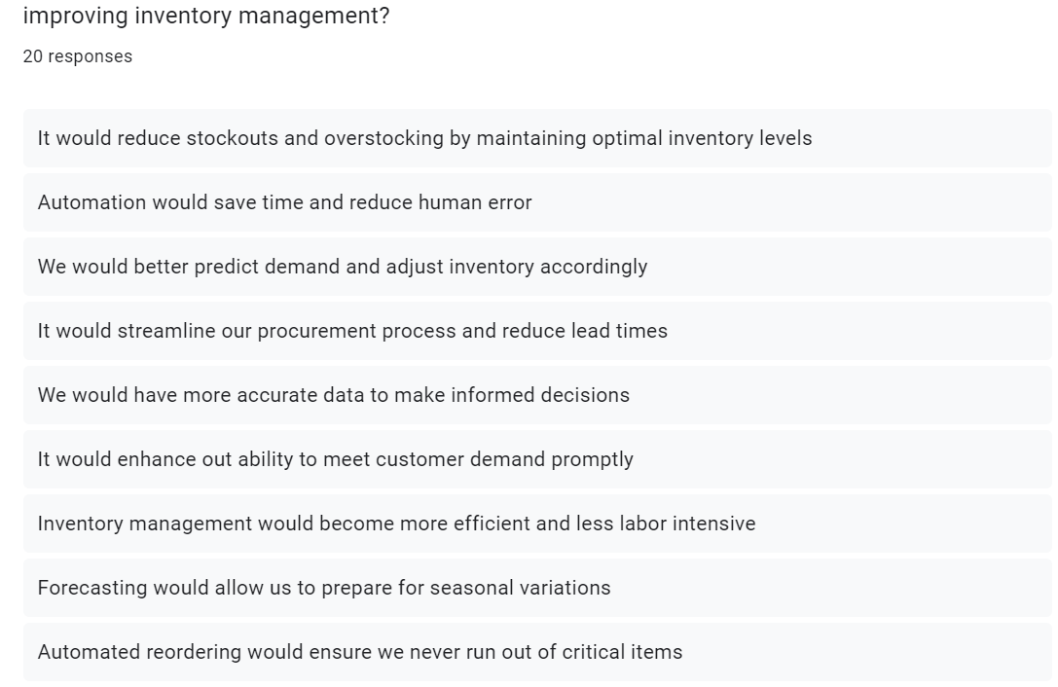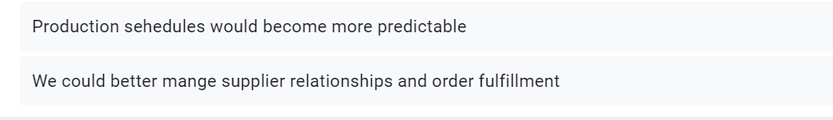

* **Requirement Analyses (Based on AS-IS Analysis)**
* **Current Business Process (Scenarios, Workflow)**
* **The current business process involves manuel data entry and paper-based record-keeping, leading to inefficiencies such as inaccuracies and discrepancies in inventory levels. Theses inefficiency cause frequent stock shortages and overages, production delays, and increased operational costs.**
* **Functional Requirement (Input, Process, and Output)**
* **Input: Manuel data entry of inventory levels.**
* **Process: Manuel reconciliation of inventory records and reordering processes.**
* **Output: Inventory reports and order forms generated through manuel consolidation.**
* **Non-functional Requirement (Performance and Control)**
* **Performance: Slow response times due to manuel data handling and processing.**
* **Control: Limited data security with frequent errors in inventory records, making the system vulnerable to inaccuracies and inefficiency.**
* **Logical DFD AS-IS System (Context Diagram, Diagram 0, Child)**
* **The AS-IS logical Data Flow Diagram (DFD) provides a visual representation of the current system:**
* **Context Diagram: Displays the interactions between the inventory management system and external entities like suppliers, customers, and production departments.**
* **Diagram 0: Details the major process within the system, showing how data flows between different functions.**
* **Child Diagrams: Breaks down the main processes into more detailed subprocesses to illustrate specific workflow steps.**

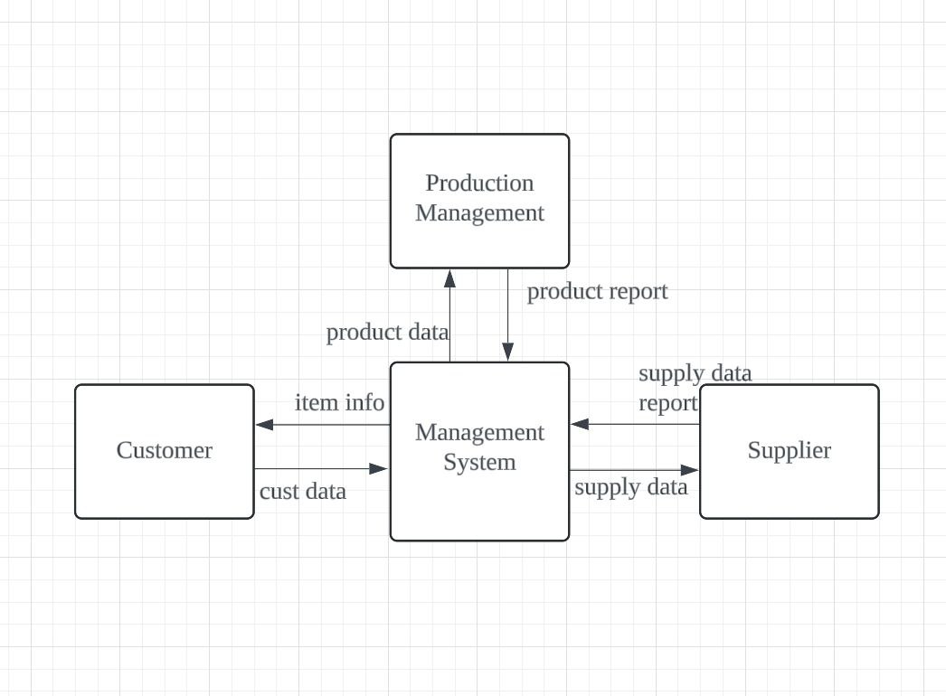

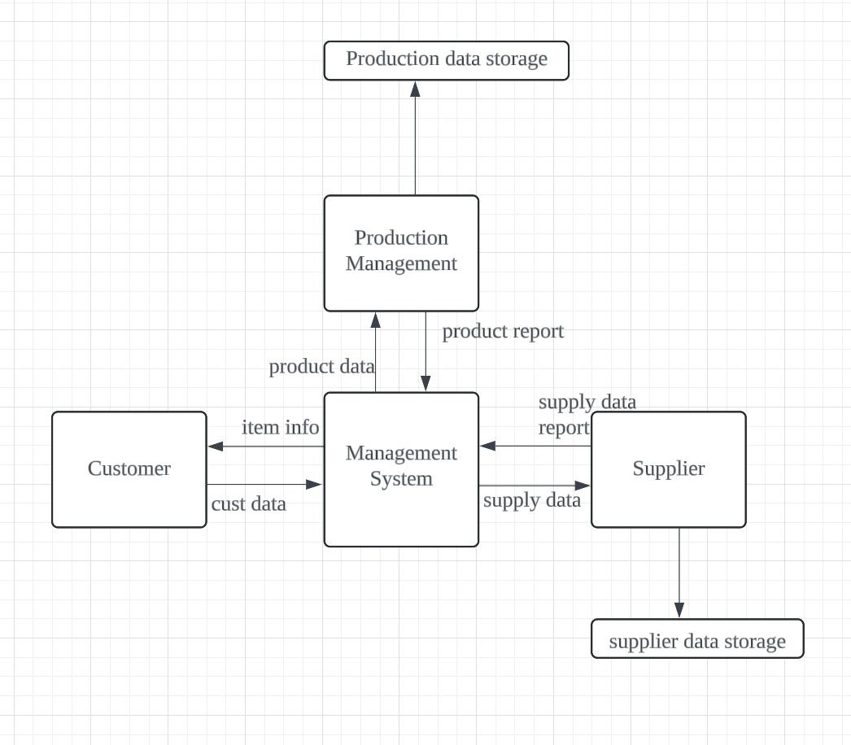

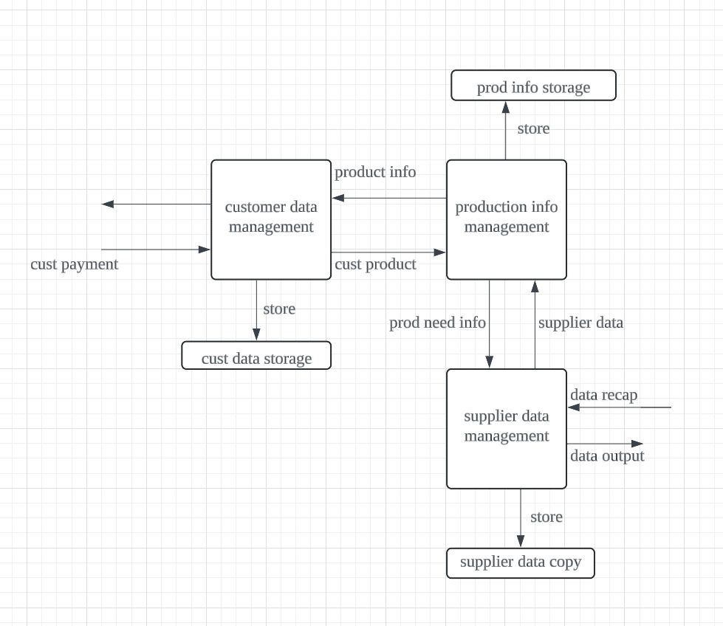

**Summary of Requirement Analysis Process**

The requirement analysis process has involved gather information through surveys, interviews, and observations understanding the current inventory managing practices and identifying areas of improvement. Key discoveries include:

The Current Business Process/Workflow: Inefficiencies in manual data enter and paper-based record-keeping leading to inaccuracies and discrepancies in inventory levels. Functional Requirements (AS-IS): Input: Manual data enter of inventory levels. Process Manual reconcile of inventory records and reorder. Output: Inventory reports and order forms. Non-functional Requirements (AS-IS): Performance: Slow respond times due to manual data handle. Control: Limited data security and frequent errors in inventory records. Based on these discoveries, the Enhanced Inventory Management System (EIMS) is designed to automate processes, improve data accuracy, provide real-time visibility, and enhance overall operational efficiency. The EIMS project represents a strategic investment in modernize inventory management practices, driving operational excellence, innovation, and growth for the company.